TA/LA Report Generator

**Overview:** The TA/LA Report generator allows a user to form individual reports for each TA/LA in the department of IST. The generator takes in raw data in the form of a .csv file and then uses that data and compiles an overview report to analyze the TA or LA’s performance.

**Unzipping the Raw data file:**

1. In Google chrome after a file is downloaded it will appear the button of the screen. Simply click on the file that was downloaded to open it.
2. A window will appear showing the opened file. Go to the top of the screen and click on **Downloads** to navigate to the **Downloads** folder.

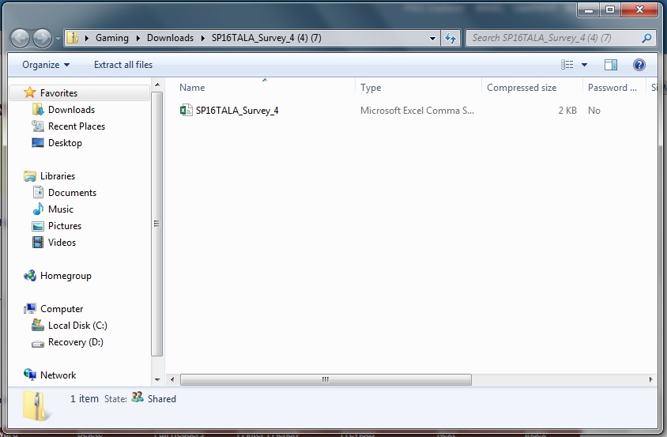

1. You should now be in the **Downloads** folder with the zipped file selected.

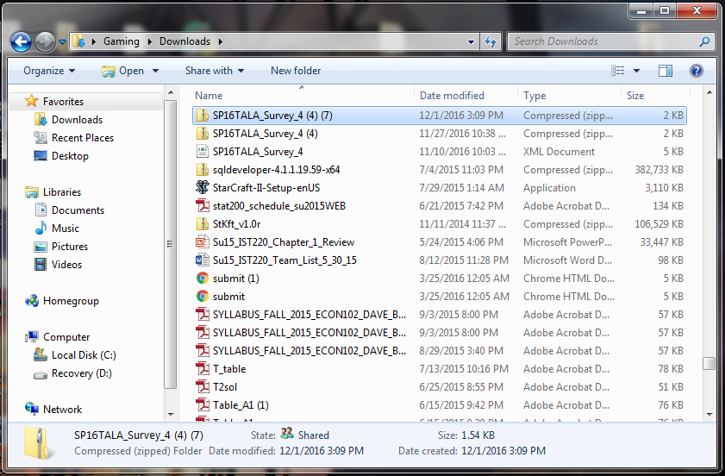

1. Right click the zipped data file and a list of folder options will appear.
2. In the folder options click on “**Extract All…**”. This will open an **Extract Compressed Folders** window.
3. In the **Extract Compressed Folders** window click on **Browse**.

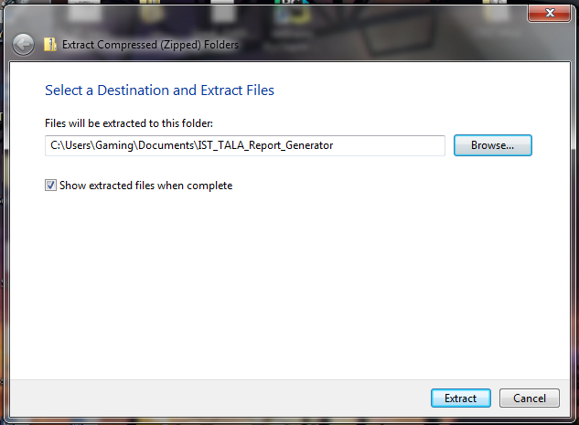

1. In the **Select Destination** window locate and select the **IST_TALA_Report_Generator** Folder. This folder is located in the **Documents** folder. The following path will lead you to the **Documents** Folder: Documents 🡪 My Documents
2. Select the **IST_TALA_Report_Generator** Folder then press Select Folder. At this point the path is set to the appropriate folder. (Steps 8 needs to be checked on her computer.)
3. Go back to the **Extract Compressed Files** window and press **Extract**.

**Note:** You should now have an unzipped data file in the specified folder to input into the application. At this point follow the instructions below on how to use the application with the newly unzipped data file.

**Location of File:** Documents 🡪 IST_TALA_Report_Generator 🡪 ”Name of downloaded data file from Qualtrics”

**Note:** If you have any reports open make sure to close them or the application will not work. If this happens simply close them and repeat steps 1 - 13.

**Application Instructions:**

1. Use the following path to locate the executable file. Documents 🡪 IST_TALA_Report_Generator 🡪 dist 🡪 main
2. Double click **main** to open the application.

**Note:** If the application receives an error simply close the application and reopen it.

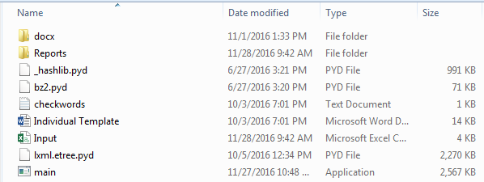

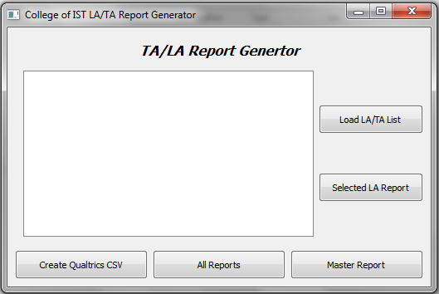

1. Click the **Master Report** button to generate a proper .csv file to input into the application. This will open a file opener window.
2. In the file opener window locate and open the data file that was just unzipped. You can locate the file using this path: Documents 🡪 IST_TALA_Report_Generator 🡪 ”Name of downloaded data file from Qualtrics” folder 🡪 ”Name of downloaded data file from Qualtrics”
3. Go back to the file explorer and locate the Input file. Location: Documents 🡪 IST_TALA_Report_Generator 🡪 dist 🡪 Input
4. Open the file named **Input.**
5. Go to the cell that contains the following text: **Please consider adding comments about the Assistant’s performance. Respectful feedback on both st...** This can be found in the cell underneath the cell that contains **Q8.**
6. Click that cell **(Location: S2)** and go to the task pane above.
7. Click on the task pane. This is the white bar above all the letters.

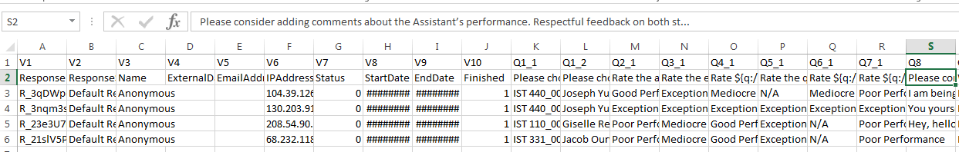

1. Go to the word **Assistant’s** and delete the apostrophe. Put the apostrophe back in.

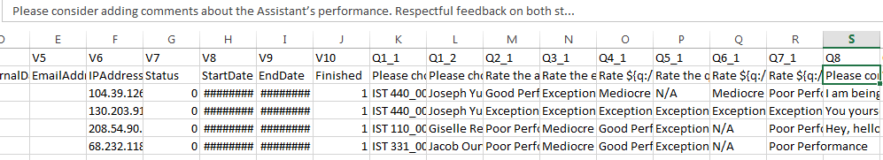

1. Close and save the Excel file. (Click Yes/Save to all windows)
2. Below is what the applications icon looks like. Simply click that to go back to the application.



1. Go back to the application and click the **All Reports** button which brings up a file opener window.
2. In the file opener window locate and open the file named **Input**. This can be navigated to using the following path: Documents 🡪 IST_TALA_Report_Generator 🡪 dist 🡪 Input

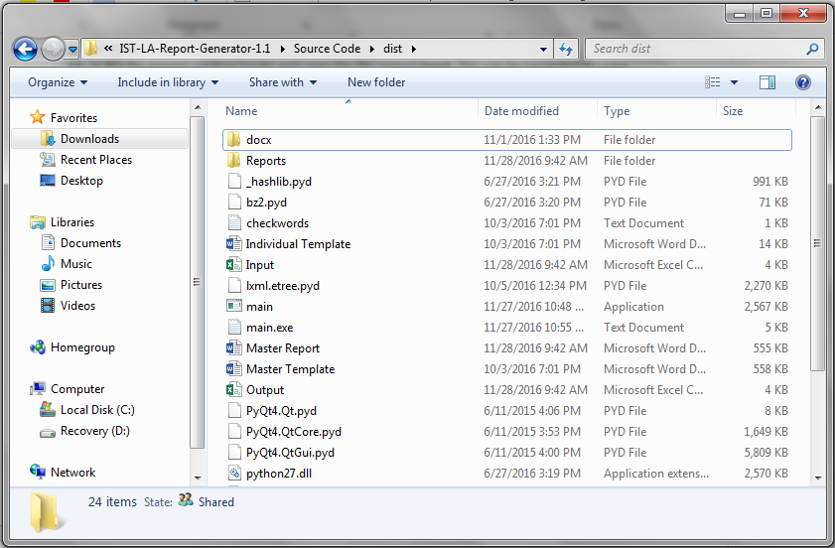

1. After opening the raw data file, the application will take a few moments to process and correctly apply the raw data to format of the Individual Template. Once the process is complete, a message box will appear stating that reports were generated in the reports folder.
2. The reports folder is located in the dist folder and can be navigated to using this path: Documents 🡪 IST_TALA_Report_Generator 🡪 dist 🡪 Reports

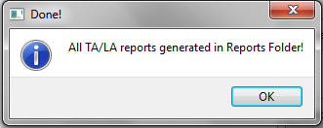

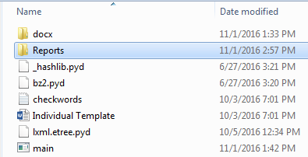

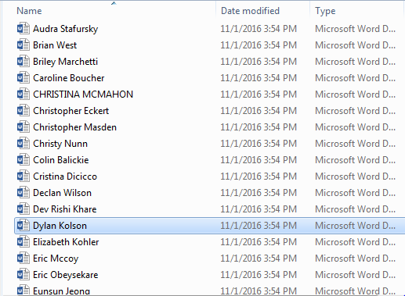

1. 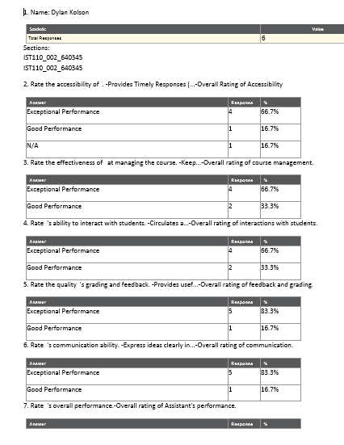Open the Reports folder and open any of the files inside. If the above steps were followed correctly then the report that you opened should follow the format of the document below.

